import pandas as pd

import psycopg2

from sqlalchemy import create_engine

**# Store CSV into DataFrame**

csv_file = "../Resources/nytbooks_data.csv"

nytbooks_data_df = pd.read_csv(csv_file)

nytbooks_data_df.head()

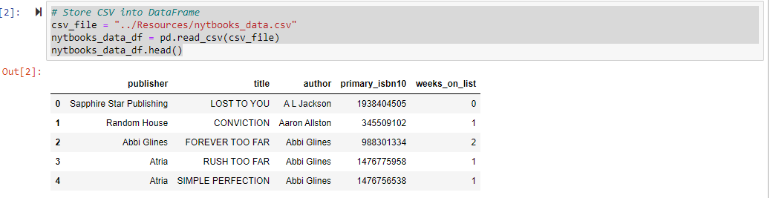

**# Create new data with select columns**

new_nytbooks_data_df = nytbooks_data_df[['author', 'primary_isbn10', 'title']].copy()

new_nytbooks_data_df.head()

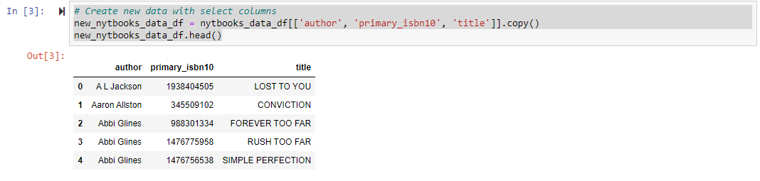

**#Store second data into a DataFrame**

csv_file = "../Resources/goodreads_data.csv"

goodreads_data_df = pd.read_csv(csv_file)

goodreads_data_df.head()

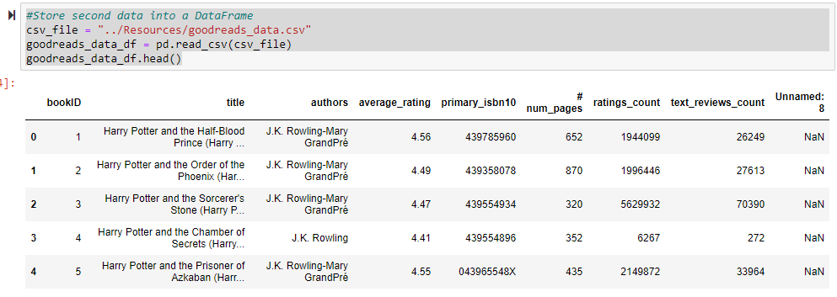

**# Clean DataFrame**

new_goodreads_data_df = goodreads_data_df[["authors", "ratings_count", "primary_isbn10"]].copy()

new_goodreads_data_df.head()

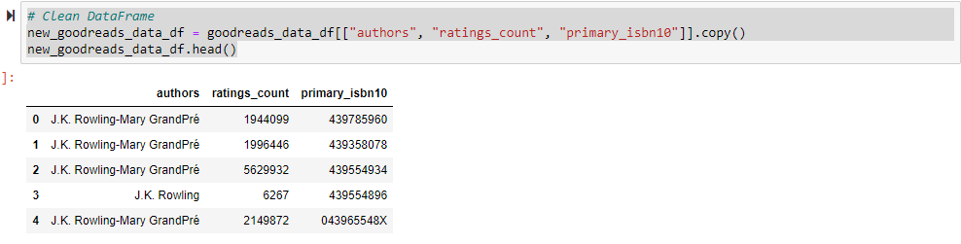

**#Connect to local database ----- MODIFY CODE TO BE RENAMED BASED ON THE DB CREATED**

rds_connection_string = "postgres:postgres@localhost:5432/customer_db"

engine = create_engine(f'postgresql://{rds_connection_string}')

#Check for tables

engine.table_names()